**ASSESSMENT 1**

Project Proposal

# Project Plan Analysis & Design

Ziyan SHEN

219323496

The project's goal is to spread awareness of "The Children's Gallery" among kids, especially those who have not had access to a foundational education. The gallery's visibility would increase thanks to this website, therefore more kids would be served.

The focus of this website's content will be the gallery's interactive digital displays, painting, sandcastle building, and other activities. This is done in an effort to convey to the intended audience why "The Children's Gallery" is such a fantastic place to be.

The user visits the website's introductory page, which displays a brief summary of the website along with images from the gallery.

The organization's programmes and services are also displayed on the "explore" website.

The "About us" page contains the company's contact details as well as its Vision and Mission.

The "Location" page lists the locations and branches that are available. Users may use it to look for branches in particular locations.

The following are the assets that will be used in this project:

|  |  |  |
| --- | --- | --- |
| **ASSET** | **USES** | **DETAILS** |
| **Main.html** | **This file is the base of all the pages in this project since this is the home page.** | **HTML file, javascript** |
| **About Us.html** | **Contains the contact information and vision and mission of the organization.** | **HTML file** |
| **Locations.html** | **Responsive page using vue.js** | **Must exist accessible navigation, exclusive folder component** |
| **App.js** | **The main JavaScript file to import and use Vue components.** | **JavaScript file for Locations.html** |
| **style.css** | **Stylesheet for all html files.** | **CSS file for Main, About Us, and Locations html files.** |
| **app.vue** | **Search page component** | **Single file component.**  **Interactive page** |

**This project proposal's goal is to bring families together and create an environment that is moral.**

Target Audience



PARENTS

A lot of parents are unaware of children's galleries. They may locate activities for their kids on this website that will benefit them both emotionally and educationally.

SCHOOLS

Schools often do educational tours, so it could be a good idea to stop at The Children's Gallery.

PEOPLE IN RURAL

AREA

It might be difficult for people in remote areas to find fresh activities for their kids. Their desire for resources can also motivate them to go to the gallery.

Creativity Demonstration

USER STORY 1

|  |  |  |
| --- | --- | --- |
| STATEMENT | ACCEPTANCE CRITERIA | PRIORITY |
| As a user, and I need to know how to get in touch with the company. | 1. Users can select the "About us" tab from the homepage.   1. 2. The organization's "About us" page should have contact information. | High priority |

USER STORY 2

|  |  |  |
| --- | --- | --- |
| STATEMENT | ACCEPTANCE CRITERIA | PRIORITY |
| As a user, I want to look up the branches that are open around me as a user. | 1. Users can select the "Location" tab from the main page.  2. The "Location" tab should be redirected to users.  3. The search box should be visible to users.  4. The user can enter the required location in a search field.   1. 5. Users must be able to see the branches that are accessible. | High priority |

USER STORY 3

|  |  |  |
| --- | --- | --- |
| STATEMENT | ACCEPTANCE CRITERIA | PRIORITY |
| As a user , I'm interested in the services offered as a user. | 1. The list of services should be visible to users on the site. | Low priority |



SCHEME: fbdd9d

COLOUR

ffffff, 00000

I made the decision to use a light, simple colour palette. A website visitor ought to feel at ease and welcomed when they arrive. This colour palette is my personal favourite because it isn't overpowering and bright.

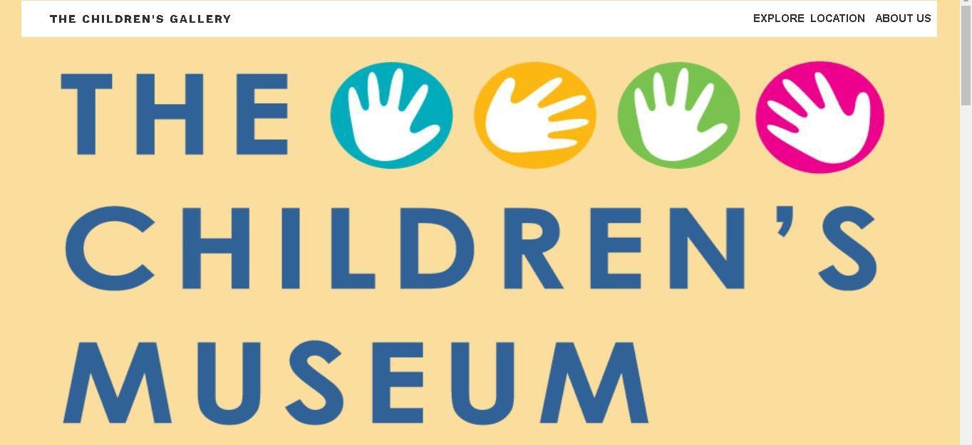

# MAIN PAGE VIEW

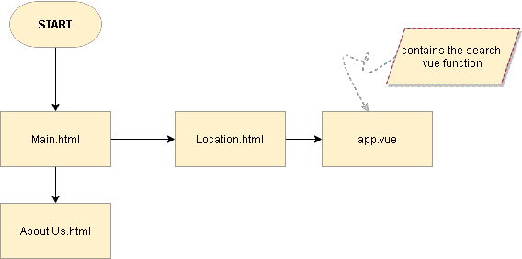

**System Analysis**

The user will be able to look for available branches on the Location page using the city they entered in the search box. When the search button/enter-key is toggled, the results are displayed on the website with the contact details for the branches.

**Technical Analysis**

This project makes use of the coding frameworks and languages HTML, CSS, JavaScript, and vue.js. Using Vue.js, the interactive and progressive website aim is made possible.

**Development Schedule**

The appropriate appointment for this project is August 4, 2022, on Wednesday.

I assess my calendar based on the importance of each assignment in light of the remaining days.

**Probability**

Each task commits to taking, on average, 2-3 days to complete. Despite my guarantees that the anticipated days would be difficult and lengthy, my research suggested that I might not be able to accurately adhere to the many requirements.

The GitHub link is